EX7 – DOMAIN NAME SERVER USING UDP
- S. Vishakan CSE – C 18 5001 196

Server Program:

#include <stdio.h>
#include <string.h>
#include <stdlib.h>
#include <sys/socket.h>
#include <netinet/in.h>
#include <arpa/inet.h>
#include <netdb.h>

#define PORT 7228
#define SIZE 30

struct DNS_Table{ //struct for the DNS table
char server_list[SIZE][100];
char ip_list[SIZE][50];
int cur_size;
};

typedef struct DNS_Table dns_table;

dns_table *local, *root, *auth; //local - 1st level, root - 2nd level, auth - 3rd level

char empty[5] = "NULL\0";

int checkIP(char *ip);
int addRecord(dns_table *table, char *server, char *ip);
void allocateIP(dns_table *table);
void printTable(dns_table *table, char *table_name);
void updateTable(dns_table *table);
void initTables();
char *fetchIP(char *req_server);

int main(int argc, char **argv){

struct sockaddr_in server, client;
int sockfd, n, addrlen, flag;
char req_server[100], *ip, req_ip[50];

initTables();
printTable(local, "Local Table");
printTable(root, "Root Table");
printTable(auth, "Authoritative Table");

printf("\n\nDo you wish to alter the local allocation table? (1 - YES, 0 - NO) -> ");
scanf("%d", &flag);

if(flag == 1){
updateTable(local);
printTable(local, "Local Table");
}

sockfd = socket(AF_INET, SOCK_DGRAM, 0);

if(sockfd < 0){
perror("Error in creating socket.\n");
}

bzero(&server, sizeof(server));
server.sin_family = AF_INET;
server.sin_addr.s_addr = INADDR_ANY;
server.sin_port = htons(PORT);

if(bind(sockfd, (struct sockaddr*)&server, sizeof(server)) < 0){
perror("Error in binding.\n");
}

printf("\nServer awaiting clients on port %d...\n", PORT);

addrlen = sizeof(client);

while(1){
bzero(req_server, sizeof(req_server));
recvfrom(sockfd, &req_server, sizeof(req_server), 0, (struct sockaddr*)&client, &addrlen);
printf("\nReceived a request for IP Address of %s from a client.\n", req_server);

ip = fetchIP(req_server);

if(ip == NULL){ //IP address does not exist
strcpy(req_ip, empty);
sendto(sockfd, &empty, sizeof(empty), 0, (struct sockaddr*)&client, addrlen);
}
else{
//pointer -> char_array conversion is necessary since pointer only sends 8 bits of data
strcpy(req_ip, ip);
sendto(sockfd, &req_ip, sizeof(req_ip), 0, (struct sockaddr*)&client, addrlen);
}

printf("\n\nReplied with IP Address %s\n", req_ip);
}

return 0;
}

int checkIP(char *ip){
//Checks for the validity of a given IP address

int valid = 1, byte;
char *ip_copy, *split;

ip_copy = (char *)calloc(50, sizeof(char));
strcpy(ip_copy, ip);
split = strtok(ip_copy, ".");

while(split){ //split pointer points to each "byte" iteratively
byte = atoi(split);
if(byte < 0 || byte > 255){
return 0;
}

split = strtok(NULL, ".");
}

return 1;
}

int addRecord(dns_table *table, char *server, char *ip){
//Add a new record into a specific DNS table

int valid;

if(table->cur_size == SIZE - 1){ //if table is full
return table->cur_size;
}

valid = checkIP(ip);

if(valid){
strcpy(table->server_list[table->cur_size], server);
strcpy(table->ip_list[table->cur_size], ip);
table->cur_size++;
}

else{
printf("\tIP Address %s is invalid.\n", ip);
}

return table->cur_size;
}

void printTable(dns_table *table, char *table_name){
//Print the current contents of a given table

int i = 0;

printf("\n\t---------------------------------------------------------");
printf("\n\t\t\t%-30s", table_name);
printf("\n\t---------------------------------------------------------");
printf("\n\t%-25s\t%s\n", "Server Name", "IP Address");

for(i = 0; i < table->cur_size; i++){
printf("\n\t%-25s\t%s", table->server_list[i], table->ip_list[i]);
}
printf("\n\t---------------------------------------------------------\n\n");
}

void updateTable(dns_table *table){
//Update a given DNS table

char serv[100], ip[50];
int i = 0, exists = 0, choice = 1, valid;

while(choice){
printf("\nEnter Server Name:\t");
scanf("%s", serv);
printf("\nEnter IP Address:\t");
scanf("%s", ip);

valid = checkIP(ip);

if(!valid){
printf("\nIP Address %s is invalid.\n", ip);
continue;
}

exists = 0;

for(i = 0; i < table->cur_size; i++){
if(strcmp(ip, table->ip_list[i]) == 0){
exists = 1;
printf("\nIP Address %s is already allocated.\n", ip);
break;
}
}

if(exists == 0){
strcpy(table->ip_list[i], ip);
strcpy(table->server_list[i], serv);
table->cur_size++;

printf("\nDo you wish to continue modifying the table? (1 - YES, 0 - NO) -> ");
scanf("%d", &choice);
}
}
}

void initTables(){
//Initialize the local, root and auth tables with some prefixed records

local = (dns_table *)malloc(sizeof(dns_table));
root = (dns_table *)malloc(sizeof(dns_table));
auth = (dns_table *)malloc(sizeof(dns_table));

local->cur_size = 0;
root->cur_size = 0;
auth->cur_size = 0;

addRecord(local, "www.google.com", "142.89.78.66");
addRecord(local, "www.yahoo.com", "10.2.45.67");
addRecord(local, "www.annauniv.edu", "197.34.53.122");

addRecord(root, "lms.ssn.edu.in", "22.32.44.5");
addRecord(root, "www.quora.com", "223.254.1.2");
addRecord(root, "www.nptel.ac.in", "108.108.108.108");
addRecord(root, "www.khanacademy.org", "1.2.3.4");

addRecord(auth, "www.brilliant.org", "32.33.11.23");
addRecord(auth, "www.youtube.com", "2.5.6.1");
addRecord(auth, "mail.google.com", "45.12.11.41");

}

char *fetchIP(char *req_server){
//Fetch the IP address of a given domain name from the DNS tables iteratively/from TLD

int i = 0;
struct hostent *he; //for TLD
char *tld_ip;

printf("\nSearching the local-level DNS table...");

for(i = 0; i < local->cur_size; i++){
if(strcmp(local->server_list[i], req_server) == 0){
return local->ip_list[i]; //found in local
}
}

printf("\nSearching the root-level DNS table...");

for(i = 0; i < root->cur_size; i++){
if(strcmp(root->server_list[i], req_server) == 0){
return root->ip_list[i]; //found in root
}
}

printf("\nSearching the authoritative-level DNS table...");

for(i = 0; i < auth->cur_size; i++){
if(strcmp(auth->server_list[i], req_server) == 0){
return auth->ip_list[i]; //found in auth
}
}

printf("\nSearching the top-level domain DNS table...");

he = gethostbyname(req_server); //gets the host entry for the domain name

if(he == NULL){ //if host entry does not exist for the domain
return NULL;
}

tld_ip = inet_ntoa(*((struct in_addr *)he->h_addr_list[0])); //get the IP address from host entry

addRecord(local, req_server, tld_ip); //cache the record in local for faster access next time

printf("\nAdded record for Server: %s with IP address: %s in local table.", req_server, tld_ip);

return tld_ip;

}

Output:

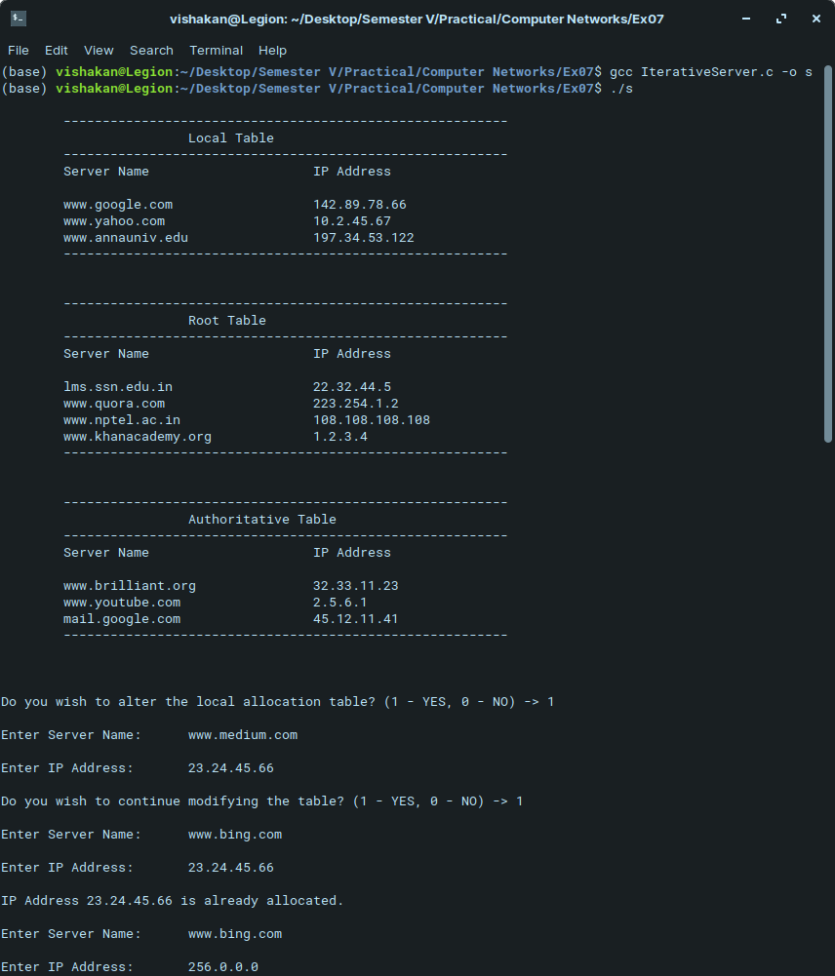
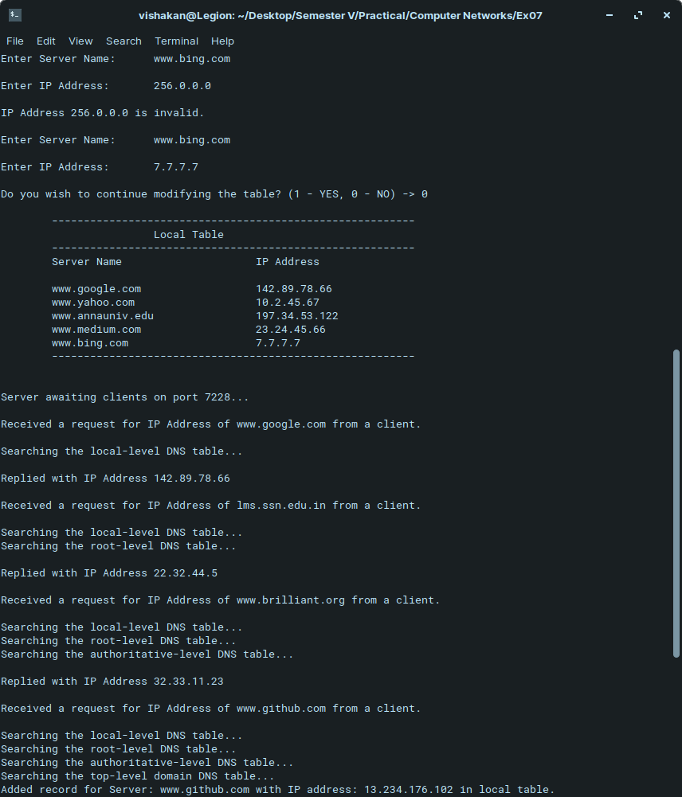
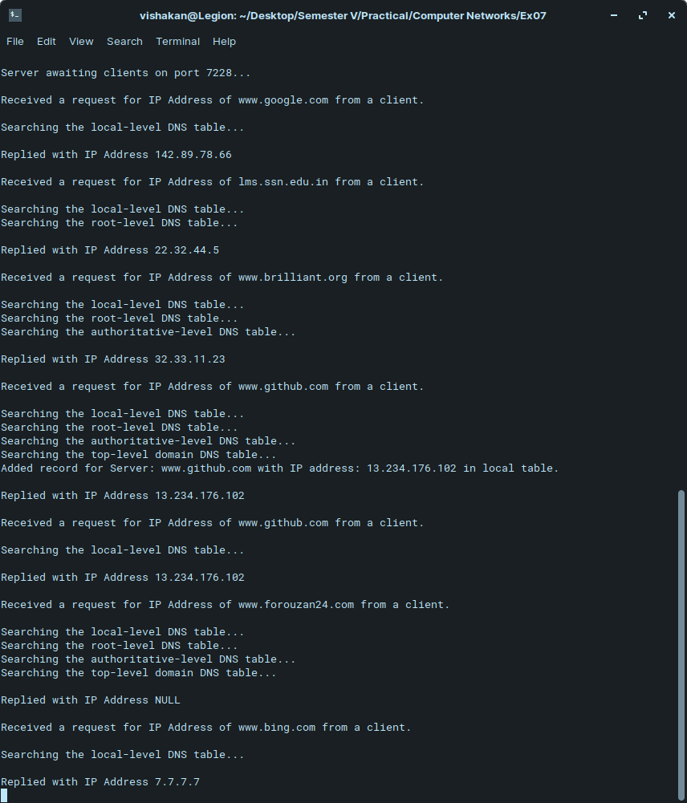
Client Program:

#include <stdio.h>
#include <string.h>
#include <stdlib.h>
#include <sys/socket.h>
#include <netinet/in.h>

#define PORT 7228

int main(int argc, char **argv){

struct sockaddr_in server, client;
int sockfd, n, addrlen, flag, choice = 1;
char req_server[100], req_ip[50];

sockfd = socket(AF_INET, SOCK_DGRAM, 0);

if(sockfd < 0){
perror("Error in creating socket.\n");
}

bzero(&server, sizeof(server));
server.sin_family = AF_INET;
server.sin_addr.s_addr = INADDR_ANY;
server.sin_port = htons(PORT);

addrlen = sizeof(server);

while(choice){
printf("\nEnter the Server's Name :\t");
scanf("%s", req_server);
sendto(sockfd, &req_server, sizeof(req_server), 0, (struct sockaddr*)&server, sizeof(server));

recvfrom(sockfd, &req_ip, sizeof(req_ip), 0, (struct sockaddr*)&server, &addrlen);
printf("The IP Address is :\t\t%s\n", req_ip);

printf("\nContinue? (1 - YES, 0 - NO) -> ");
scanf("%d", &choice);
}

close(sockfd);

return 0;
}

Output:

